**Hands On Microcontroller : From Theory To Practice**

**Automatic Gate Opener Using Arduino**

**Submitted by**

**Gayatri (PRN-23070123055)**

**Hussain (PRN-23070123061)**

**Soham (PRN- 23070123065)**

**Labdhi (PRN-23070123078)**

**Under the Guidance of**

**Dr. Shilpa Hudnurkar**

**Department of Electronics and Telecommunication Engineering,**

**Symbiosis Institute of Technology**

**Pune 412115, Maharashtra, India**

# **Mini Project Report**

**Automatic Gate Opener using Arduino**

## **Group Members**

1. Soham Jade: 23070123065
2. Hussain Tayyebi: 23070123061
3. Labdhi Mandovara: 23070123078
4. Gayatri Apotikar: 23070123055

## **Declaration**

We hereby declare that the project titled Automatic Gate Opener using Arduino is our original work and has not been submitted elsewhere. All sources have been acknowledged appropriately.

## **Acknowledgement**

We express our sincere gratitude to our faculty members, mentors, and peers for their support and guidance throughout this project. Special thanks to Dr. Shilpa Hudnurkar for their invaluable insights.

## **Index**

**Mini Project Report**

**Group Members**

**Declaration**

**Acknowledgement**

**Index**

**Abstract**

**Introduction**

**Block Diagram and Photo of the project**

**Selection of Components**

**List of Components:**

**Component Description**

**1.** **Arduino UNO R3**

**2.** **HC-SR04 Ultrasonic Sensor**

**3.** **SG90 Servo Motor**

**4.** **Breadboard & Jumper Wires**

**Working and Circuit Diagram**

**Problems Faced / Troubleshooting**

**Application of the Project**

**1.** **Gate Automation:**

**2.** **Smart Parking Systems:**

**3.** **Security Gates:**

**4.** **Industrial Automation:**

**Conclusion**

**Future Scope of Work**

**1.** **Integrating RFID/NFC for vehicle authentication:**

**2.** **Implementing IoT-based monitoring for remote toll management:**

**3.** **Using solar power to make the system energy-efficient:**

**References**

**Appendix (Datasheet)**

### **Abstract**

This thesis introduces an affordable and scalable Arduino-based automated gate system for improving traffic flow while minimizing manual operation. The system deploys ultrasonic sensors (HC-SR04) to detect vehicles approaching the toll gate and a servo motor (SG90) to control the opening and closing of the toll gate. The toll gate setup is powered by an Arduino UNO and exemplifies the use of embedded systems to enhance transportation infrastructure. Future developments of the system are proposed with enhancements such as RFID for vehicle identification and IoT-based monitoring to increase security, efficiency, and ease of remote management. The use of solar power is also proposed to improve power consumption efficiency and provide remote opportunities. The project is considered a smart, sustainable, and practical solution for modern toll management.

## 

### **Introduction**

Using automation on physical entry gates can improve access control by reducing human interference and delays, which leads to positively improving the way these gates operate. This project has an Arduino based system that uses sensors to detect when a person or car is approaching and automatically open and close the gate for access. There are also several additional components along with the Arduino, such as ultrasonic sensors, servo motors, and many others that help make operation of the gate smooth and safe. Automation can help reduce operational costs, improve speed of response and eliminate human error experienced with new gate management on the daily basis. Overall, automation improves the function and reliability of entry systems and allows for scalable upgrades for the future along with automated and smarter access control systems.

### **Block Diagram and Photo of the project**

Block Diagram

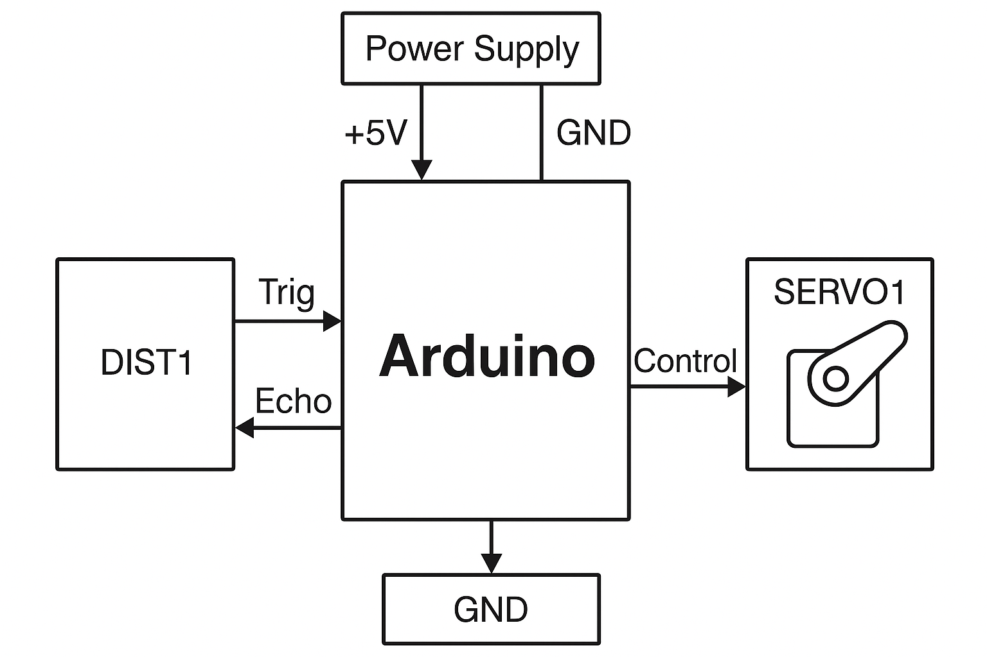

Figure 1.1

Project photo

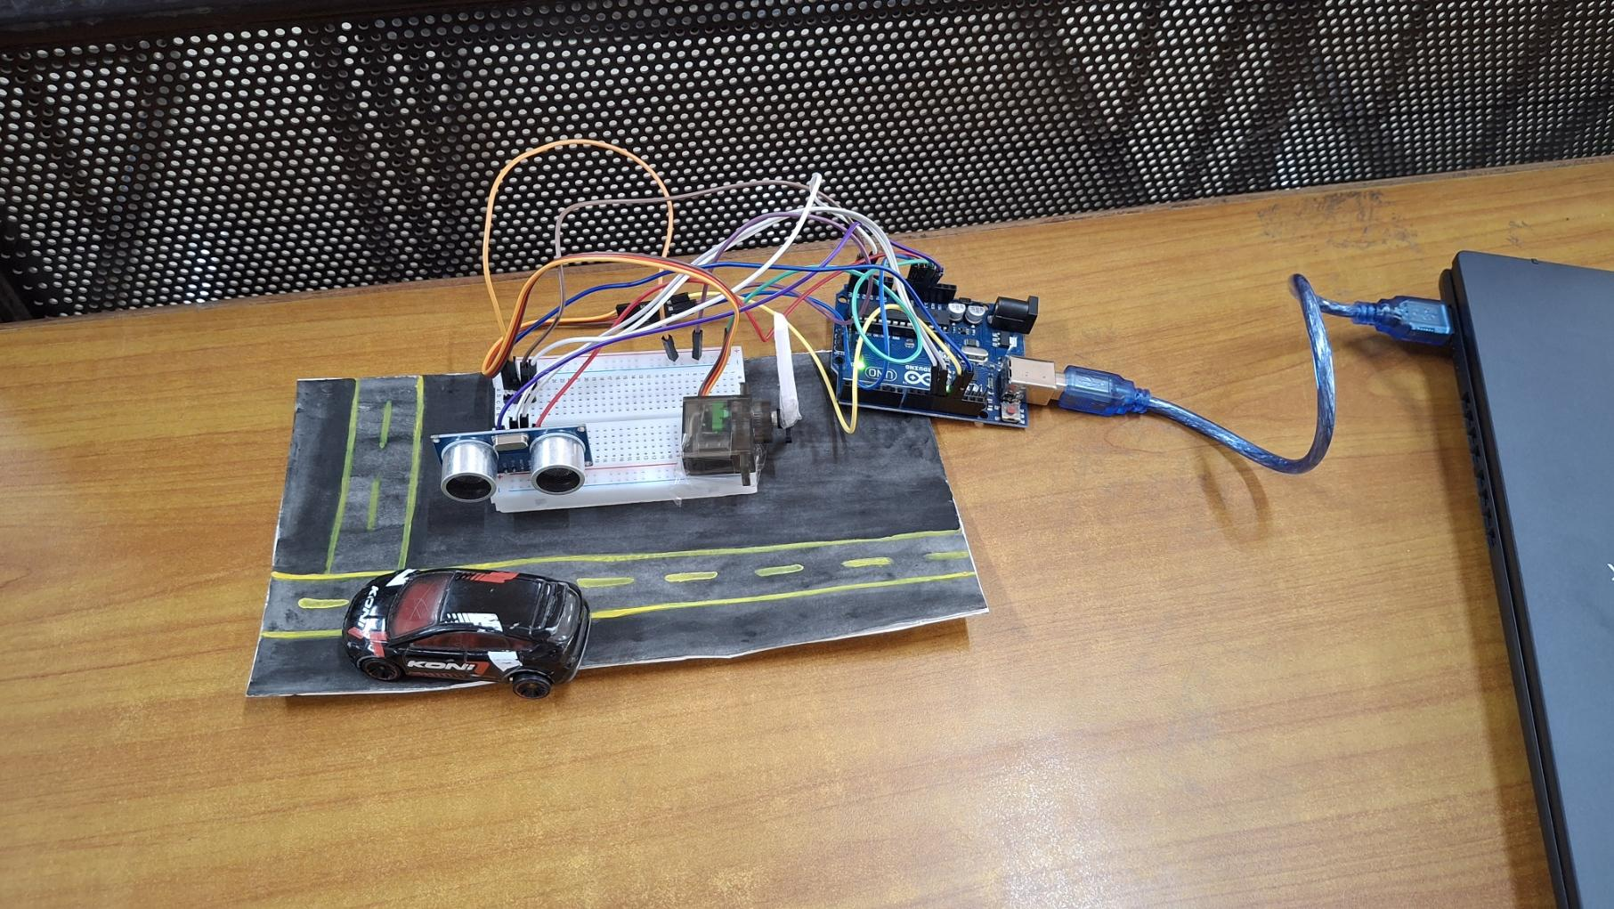

Figure 1.2

### **Selection of Components**

1. Arduino UNO R3
2. HC-SR04 Ultrasonic Sensor
3. SG90 Servo Motor
4. Breadboard & Jumper Wires

(Photo of the project is uploaded where we can see the components)

### **List of Components:**

Component list

|  |  |  |  |
| --- | --- | --- | --- |
| Components | Quantity | Specification | Purpose |
| Arduino UNO R3 | 1 | ATmega328P | Microcontroller |
| Ultrasonic Sensor (HC-SR04) | 1 | 2-400 cm range | Distance Measurement |
| SG90 Servo Motor | 1 | 9g, 180-degree rotation | Gate control |
| Breadboard and jumper wires | 1 | - | Component |

Table 1

### **Component Description**

#### **Arduino UNO R3**

A popular microcontroller board based on the ATmega328P, used for building digital devices and interactive objects that can sense and control the physical world.

Arduino UNO R3

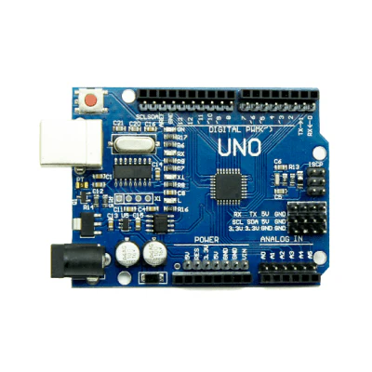

Figure 2.1

#### **HC-SR04 Ultrasonic Sensor**

Measures distance by sending ultrasonic waves and calculating the time taken for the echo to return, commonly used for obstacle detection.

HC-SR04 Ultrasonic Sensor

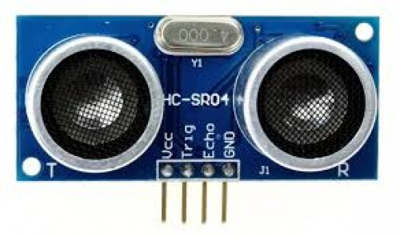

Figure 2.2

#### **SG90 Servo Motor**

A small, lightweight servo motor capable of precise angular movement, ideal for robotic arms and motion control applications.

SG90 Servo Motor

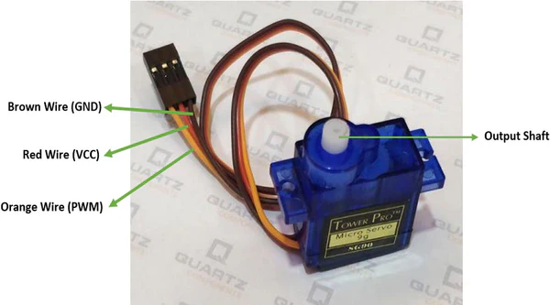

Figure 2.3

#### **Breadboard & Jumper Wires**

A solderless platform used to prototype electronic circuits easily, with jumper wires for quick and reusable connections.

Breadboard and jumper wires

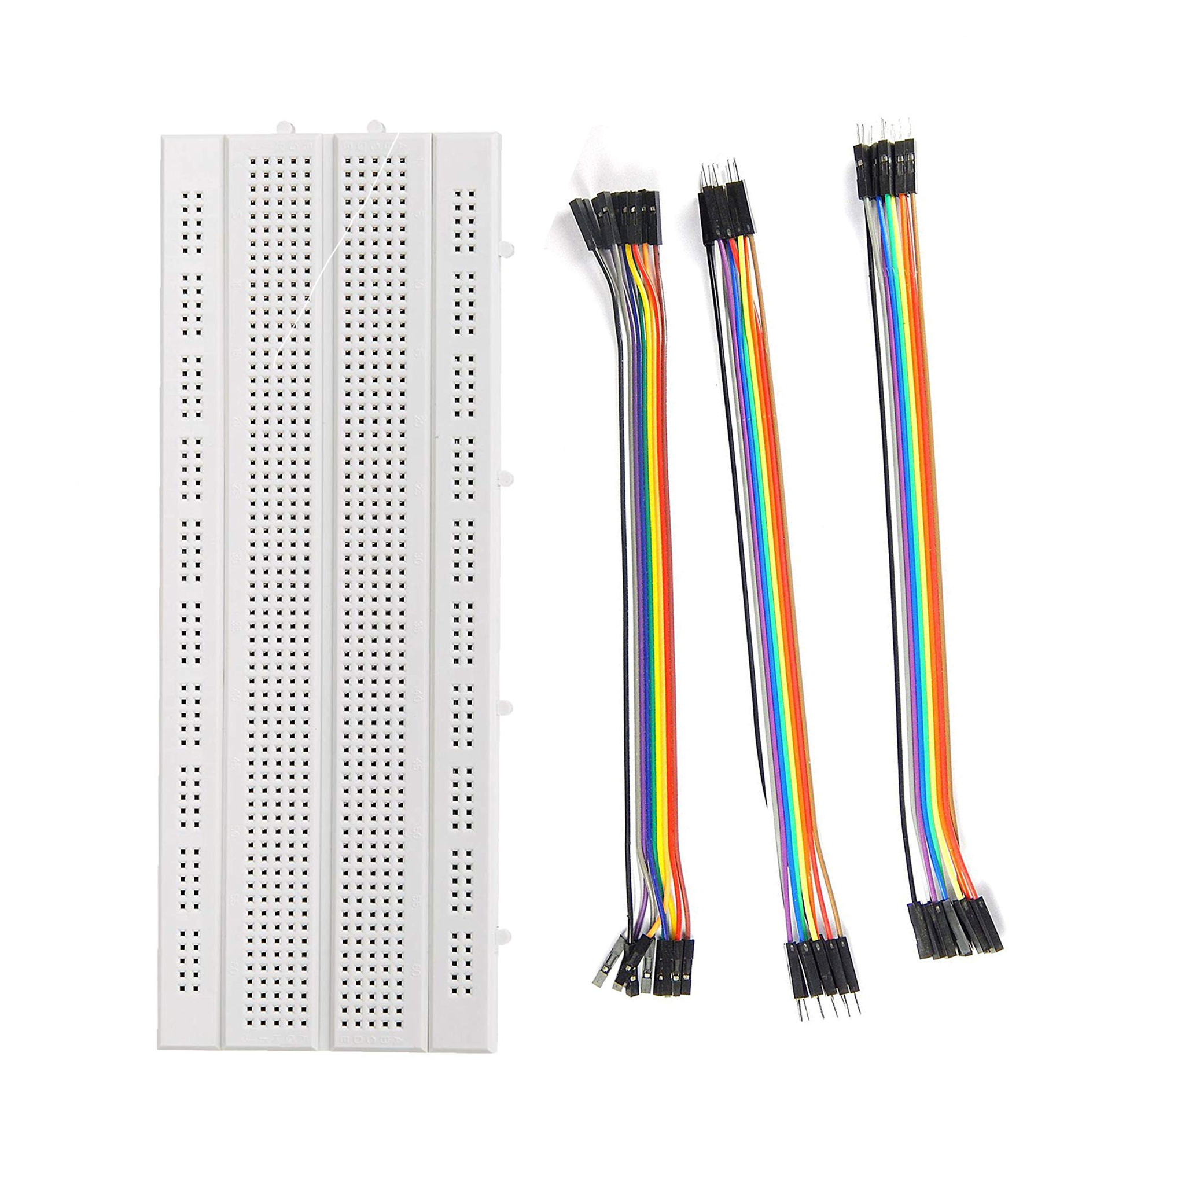

Figure 2.4

### **Working and Circuit Diagram**

The ultrasonic sensor emits an ultrasonic pulse and detects its reflection off a nearby object, such as a vehicle. The Arduino processes the reflected signal to calculate the distance to determine whether a vehicle is near the gate, which will activate the servo motor that opens or closes the gate automatically. The sensor and servo motor are mounted on a breadboard connected to an Arduino Uno as shown in the image. While a toy car is used as a substitute for a real car to simulate the car driving towards the gate, the entire system is powered via USB to a laptop. The road layout used is handmade, which allows for a visual demonstration of how the project operates. This setup gives an adequate representation of how automation can be used in gates in the real world through simple electronic components.

Circuit Diagram

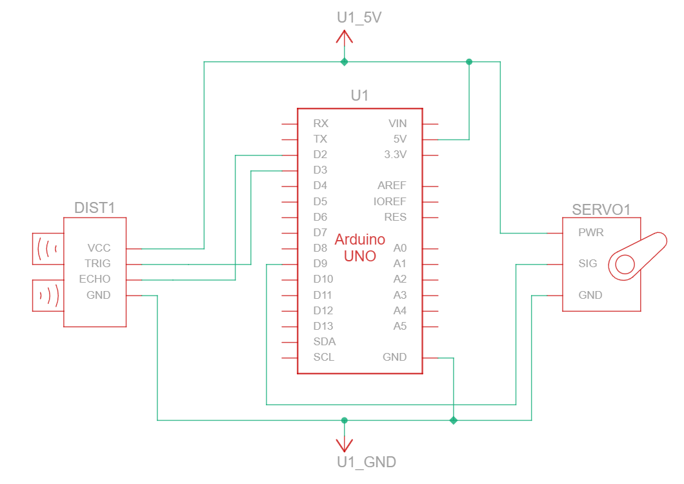

Figure 3.1

Simulation Photo (tinker cad)

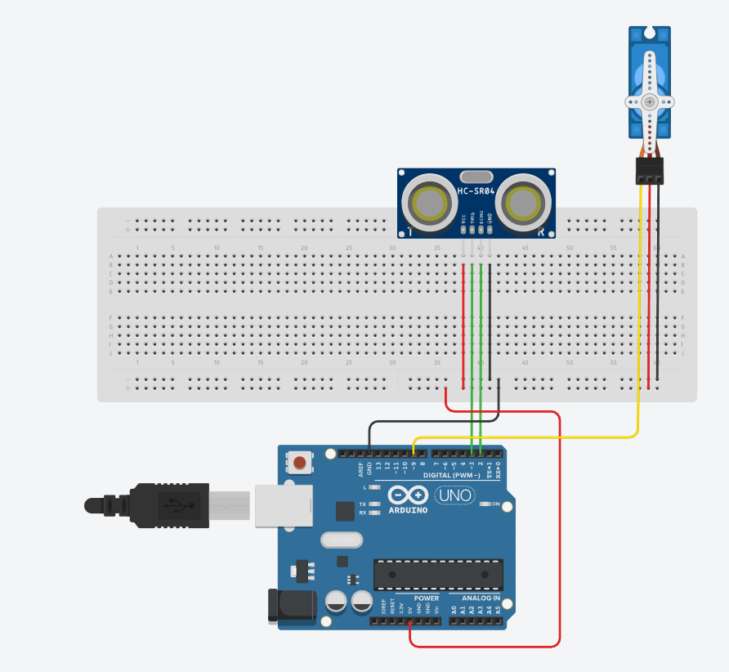

Figure 3.2

### **Problems Faced / Troubleshooting**

1. Inaccurate Distance Measurement: - Calibrated sensor sensitivity.
2. Servo Jittering: - Use appropriate delay and smoothing in code.

### **Application of the Project**

#### **Gate Automation:**

Decreases manual labour at gates by automatically sensing vehicles and operating the gate through sensors and servos. Improves traffic flow and lessens human involvement.

#### **Smart Parking Systems:**

Utilized at automated parking lots to engage presence sensing to see if a vehicle is parked and for directing drivers towards available parking. Improves space use and reduces congestion in busy areas.

#### **Security Gates:**

Implemented in secure areas to permit traffic flow by authorized personnel/vehicles only. Increases safely in secure areas through integration with RFID, biometrics, or a license plate recognition system.

#### **Industrial Automation:**

Used to manage automated access to industries for employee and vehicle access. Makes workflows easier while enhancing security by monitoring and controlling flows in sensitive areas.

### **Conclusion**

This project successfully showcases an Arduino-based automatic gate system that detects vehicles using an ultrasonic sensor, and uses a servo motor to open and close the gate. The project communicates how utilizing automation replaces manual gate actions, allowing vehicles to pass by much faster, and with less human contact. While this project is a scaled down model and only uses basic electronic components, it demonstrates that low-cost and scalable moves can be made toward the advancement of automation in gates. There is an opportunity to make the system even better; for example, RFID can be integrated into the design to allow for automatic identification of vehicles, and IoT can be used to gather data in real time and monitor traffic remotely. Overall, this project was used as a real-life example of embedded systems in action, as well as a step towards building smarter infrastructure.

### **Future Scope of Work**

#### **Integrating RFID/NFC for vehicle authentication:**

The incorporation of RFID technology into this project allows for vehicle identification and payment at parking places through automatic vehicle recognition. Each vehicle could have an RFID tag that contains unique identification information and an RFID reader at the gate to be able to read the tag in the vehicle as it approaches. Then the Arduino could check the tag data, and if it were valid, indicate for the servo motor to open the gate, thus requiring no human interaction for the process to continue. This adds to the system by being more efficient, secure, able to facilitate automated payment, as well as vehicle tracking.

#### **Implementing IoT-based monitoring for remote toll management:**

The automated gate system could be integrated with IoT (Internet of Things) technology to support remote monitoring and control. By making use of an IoT platform (e.g., Blynk, Thing Speak) to connect an Arduino with a Wi-Fi module (e.g., ESP8266), real-time data on vehicle detection, gate status, and system performance can be sent to the cloud. This allows gate operators to monitor gate status from a smartphone or computer, receive alerts for malfunctions, and continuously track vehicle movement through the gate. This type of system increases transparency, efficiency, and convenience to the process.

#### **Using solar power to make the system energy-efficient:**

Solar energy could be utilized to make the gate system more sustainable and reduce its reliance on outside power. A small solar panel could be installed to recharge a rechargeable battery that will power the Arduino and any other components connected to it (sensor, servo motor, communication modules, etc.). A charge controller could also be added, which would control battery charging and also prevent overvoltage. This approach should allow for the automated gate system to continue its operations even if placed in remote areas where there is no access to the grid, resulting in reduced operational costs while developing sustainable infrastructure.

### **References**

1. Arduino Official Documentation - <https://www.arduino.cc>
2. Servo Motor Working Principles <https://circuitdigest.com/article/servo-motor-working-and-basics>

### **Appendix (Datasheet)**

1. Arduino UNO r3 datasheet [A000066.PDF](https://drive.google.com/file/d/12MJrabNmhdFh0ZNhUIMw4dlyKIcHJekl/view?usp=drive_link)
2. HC-SR04 Ultrasonic Sensor Datasheet [HC-SR04.PDF](https://drive.google.com/file/d/1727S5HA7fSYh2puSJ77GwGMQt2kORKOK/view?usp=drive_link)